Mobile Application Idea

A Game Guide/Walkthrough of (Spyro 2, maybe expand into the other games after), this app will include a 100% walkthrough of the game alongside info on the game and secrets etc.

What to include in the walkthrough:

* 100% guide = locations of all special items and gems + normal playthrough guide.
* Characters
* Secrets
* Extra Stuff, facts?
* Maybe some info about the older titles and comparing it to the remaster

**Home Page:**

**Description of Game**: Spyro 2 Gateway to Glimmer or Riptos Rage depending on the country you live in is a classic platformer developed by Insomniac Games and published by Sony Computer Entertainment for the PlayStation 1 in 1999. It is the second game in the Spyro Trilogy released for the PlayStation 1. It was remastered in 2018 for the PlayStation 4 by Toys for Bob and published by Activision.

**Plot**: In the game you play as, Spyro the Dragon who after defeating Gnasty Gnorc takes a vacation to Dragon Shores. The portal he enters accidentally takes him to the land of Avalar because the Professor, Elora and Hunter are trying to bring a dragon to Avalar. A sorcerer, known as Ripto, has invaded the world of Avalar and is wreaking havoc on its citizens with his magic. Spyro must travel through the land of Avalar, undoing the damage done by Ripto and ultimately defeating him.

**Characters:**

**Spyro the Dragon:**

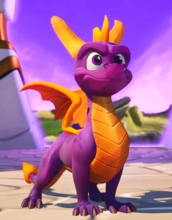Spyro the Dragon is the main protagonist of this game. Spyro is a young purple dragon that comes from the Artisans World. He is known for being courageous, headstrong, eager, and arrogant. He has a strong sense of heroism, friendliness, and has a fiery personality.

Spyro has many abilities, his main attacks consist of charging his opponents with his horns and breathing fire at them. Because he is young, Spyro cannot fly very well and cannot breathe a continuous stream of fire; instead, he just spits arrow-shaped fire bursts and glides from place to place. During the game Spyro attains different abilities from money bags such as swimming, climbing and head bashing.

**Sparx the Dragonfly:**

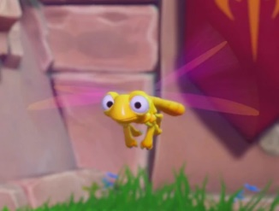Sparx the Dragonfly is Spyros closest companion. Dragonflies offer protection for young dragons such as Spyro. Without Sparx, Spyro would be susceptible to being killed or defeated in a single hit. He too has the same mischievous personality as Spyro, but he is very protective of him. Sparx also acts as Spyro's health meter. Whenever Spyro takes a hit, Sparx's colour changes, from golden yellow, to blue, to green, and then ultimately disappearing, leaving Spyro vulnerable to defeat upon the next hit. To prevent that, Spyro either flames or charges at small creatures called "fodder" to release a Butterfly, which Sparx devours, to recover one hit point in the process. Sparx can also collect nearby gems and treasure for 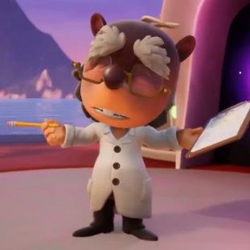Spyro.

**The Professor:**

The Professor is very stout with a large head, teal eyes, grey hair, and eyebrows. He wears glasses, a white lab coat, and black shoes. The Professor is an intellectual individual who is always looking for solutions. He is always seen carrying around a pencil and his notepad to write down the coordinates from his studies. He is an ally to Spyro, throughout the game he gives Spyro tasks to do in order to earn more orbs.

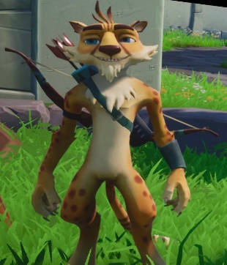**Hunter the Cheetah:**

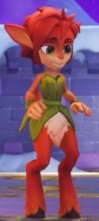Hunter the Cheetah is a supporting character native to Avalar. Hunter is a tall anthropomorphic cheetah, he has bright orange colour with brown spots all over his coat, as well as a bright yellow underbelly and goatee, and lighter orange on his paws, he also has somewhat prominent brown eyebrows, as well as bright blue eyes. Hunter is a laid-back, physically talented, and somewhat gullible character. While he's a loyal friend to Spyro and is knowledgeable about basic tasks (e.g., jumping), he has trouble grasping the gravity of Spyro's missions. Hunter is, at times, naïve and cowardly, and he can be tricked relatively easily.

**Elora the Faun:**

Elora is a faun from Avalar, she initially greets Spyro and also gives him the guidebook for his journey. Elora has blue eyes and purple eyeshadow, her top torso has skin with a small green corset, and she has a fox-like tail. Elora is an expert on the people of Avalar, becoming the natural choice when it came to helping Spyro defeat the evil Ripto. She is a strong leader in times of crisis, being an essential force in keeping the peace between the worlds during Ripto's invasion.

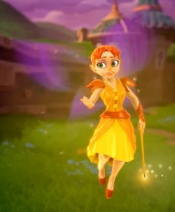**Zoe the Fairy:**

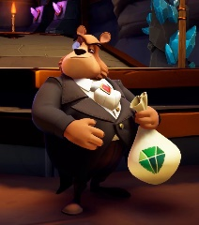Zoe is a summer fairy who offers Spyro advice and serving as a checkpoint for him throughout each of the Realms he visits. She is particularly helpful to newer players and is essentially considered a tutorial. Zoe's overall appearance features her having green eyes, ginger red hair, and a fair complexion.

**Moneybags the Bear:**

Moneybags is a bear from Avalar who acts as a neutral character. Moneybags is an upper-class, money-grubbing, and somewhat deceitful conman who is infamous for charging Spyro exorbitant fees, paid in Gems, in order for Spyro to advance in certain areas (whether it would be by learning a new skill, unlocking doors, or making passages). The costly prices are eventually paid by Spyro, much to the delight of Moneybags.

**Level Appearance**

* Glimmer: Bridge Crossing - 100 Gems.
* Summer Forest (1): Learn to Swim - 500 Gems. (2): Lower Wall to Aquaria Towers. - 400 Gems
* [Aquaria Towers](https://spyro.fandom.com/wiki/Aquaria_Towers): Borrow Submarine - 100 Gems
* [Autumn Plains](https://spyro.fandom.com/wiki/Autumn_Plains) (1): Learn to Climb - 500 Gems. (2): Open [Zephyr](https://spyro.fandom.com/wiki/Zephyr) Portal. - 400 Gems. (3): Access to [Shady Oasis](https://spyro.fandom.com/wiki/Shady_Oasis) - 400 Gems. (4): Open [Icy Speedway](https://spyro.fandom.com/wiki/Icy_Speedway) Portal - 100 Gems
* [Crystal Glacier](https://spyro.fandom.com/wiki/Crystal_Glacier): Bridge Crossing - 200 Gems
* [Magma Cone](https://spyro.fandom.com/wiki/Magma_Cone): Use Elevator - 200 Gems
* [Winter Tundra](https://spyro.fandom.com/wiki/Winter_Tundra) (1): Learn [Headbash](https://spyro.fandom.com/wiki/Headbash) - 1000 Gems. (2): Open [Canyon Speedway](https://spyro.fandom.com/wiki/Canyon_Speedway) Portal - 200 Gems

Total: 4100 Gems (5900 Gems total for Spyro before Ripto)

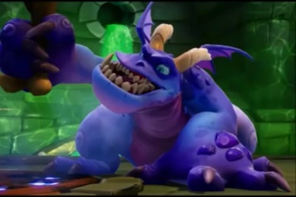**Crush:**

Crush is the more dim-witted minions of Ripto. Crush is strong yet unintelligent. His stupidity ends up getting him crushed during a fight with Spyro. Crush first fought against Spyro underneath Summer Forest Castle, but eventually the roof fell in on top of him and knocked him out.

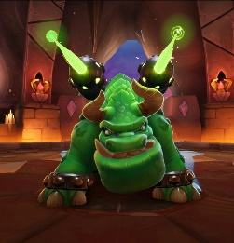**Gulp:**

Gulp is the stronger of Ripto’s two minions. Gulp is a brutish yet fairly intelligent creature. He is extremely loyal to Ripto. Gulp can ingest certain objects and spits out its harmful qualities at his opponents, such as spewing out waves of green energy after devouring a metal barrel.

**Ripto:**

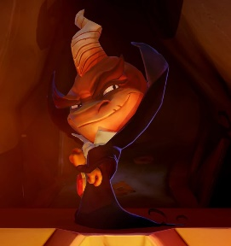Ripto is the main antagonist of this game. Ripto is a riptoc (small dinosaur) and a persistent enemy of Spyro. He also has two minions serving under him. Ripto is a despicable madman who enjoys power simply for the sake of it. He delights in causing all sorts of trouble and havoc with his magic, and is known for his general disgust for Dragons. In truth, Ripto despised his small stature, and he took it out on the world to prove that his wrath was much bigger and scarier than his modest size suggested. Frustrated, short tempered and spiteful, Ripto pulled off deception and trouble that would suit a large, intimidating creature.

**Walkthrough:**

Separate into headings and subheadings, with each homeworld then each level within that homeworld. Get video recordings of every orb or a video for each world collecting the orbs. Get screenshots of different key items and characters so I can put it into my app rather then taking the pictures from google?. Write out paths of levels or level layouts with all info that is needed.

**Summer Forest:**

* **Summer Forest:**
* **Glimmer**
* **Colossus:**
* **Idol Springs:**
* **Hurricos:**
* **Sunny Beach:**
* **Aquaria Towers:**
* **Ocean Speedway:**
* **Crush’s Dungeon:**

**Autumn Plains:**

* **Autumn Plains:**
* **Crystal Glacier:**
* **Breeze Harbor:**
* **Zephyr:**
* **Scorch:**
* **Fracture Hills:**
* **Magma Cone:**
* **Shady Oasis:**
* **Metro Speedway:**
* **Icy Speedway:**
* **Gulp’s Overlook:**

**Winter Tundra:**

* **Winter Tundra:**
* **Mystic Marsh:**
* **Cloud Temples:**
* **Robotica Farms:**
* **Metropolis:**
* **Canyon Speedway:**
* **Ripto’s Arena:**

**Dragon Shores:**

* **Dragon Shores:**

**Secrets:**

All secrets in the game aswell as maybe a glitch showcase of both the new and old game with explanations of how to perform them (stretch goal).

**Comparison:**

Compare the old game to the remaster, what changed about it from characters to levels to orbs.